Neighborhood Meeting #1 for ‘Ewa DP Update
DPP X Keith Mattson, LLC x Neighborhood Board #23 ‘Ewa
- Keith Mattson, LLC - Introduction
- DPP – Min Bu, Imelda Carlos Fernandez. Min’s introduction of staff and about EDP
- Neighborhood Board #23 – Alexander Gaos and John Rodger
Meeting Notes:
About NB board members:
- Alexander Gaos – Vice Chair for 7 years, he serves under both on port and transportation committee (?), active board member. He’s also a researcher with NOAA, MSc Biology. He cares about community. He bikes to work, from Ewa Beach to Ford Island using the Pearl Harbor bike path connection.
- John Rogers – a cyclist, volunteer with HBL, retired military. He has lots of time to do volunteer work.

- Quick flush out from the NB before the start of the interview: growth is happening in Ewa, need to focus on connectivity, safety, flood zones in a few areas in Ewa moku, Kalaeloa land transfer, its process and impacts. Also, one positive note is that – keeping quality of life is a good thing in Ewa. Overall, the timing with EDP Update is good with what is going on simultaneously.

Q1: Top concerns?
- Traffic— on the Ft. Weaver Road as the main entry to Ewa Beach. What comes from town is funneled through there (for ‘Ewa Beach area).
- Development within Wai Kai and Hoakalei will exacerbate traffic issues in and out of Ewa coming from Ft Weaver Road, and down to Keoneula Blvd, especially the one leading to Wai Kai wave pool. Keoneula Blvd is a dead end, on the other side is Tripoli Rd. that could connect us over to Nimitz Beach and Kalaeloa area. Essex road that could connect to Tripoli Rd is not accessible at this moment.
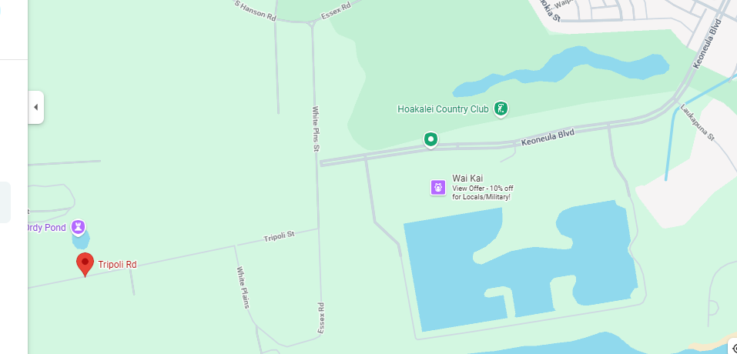
- New development proposed in Wai Kai—Lu‘au – temporary and permanent lu’au with permits sought for hosting 200 people a night, meaning bringing in more traffic (i.e., big busses) into the community.
- Community’s request—asking Keoneula Blvd to be connected to Tripoli to ease connectivity. Kalaeloa area is very isolated, connecting roads is the easiest and quickest way, giving access to community, activating area, providing alternate road for buses. White Plain beach is also on the other side. Priorities? Make community happy but always faced with overlapping jurisdictional issue.
- Safety issue (recent carjacking incident) in Kalaeloa (near White Plain beach).
- HCDA updated Master Plan on Kalaeloa mentions about these connections.
- Management of Kalaeloa area under HCDA, process that takes too long. State hasn’t done anything with it. Example Kapolei Parkway – took forever – rebuild, repave, and refix it. Understanding jurisdiction of roads and sidewalks is frustrating.
- Education and opportunities – how the schools are running and what’s going on in the classroom, community have shown big frustration—regarding the overcrowding of some elementary schools (?)

Q2: Community biggest source of pride in Ewa?
- High school football team!
- One‘ula beach park—finally some movement (improvement), after decade of frustration, and White Plain Beach—place of gathering where community show a lot of love and respect towards each other, and one of the bright spot in the whole Ewa moku area.
- Pride living here in Ewa as blue collar, not shame anything like that. “The underdog, more grit” mentality.
- Volunteer activities and efforts with Council members – cleanup with communities. Popular one along West Loch – along Kapapauhi Park – with often nearly 100 people show up to clean mangrove. Organized by HOH808? Mālama Kapapapuhi - Hui o Ho`ohonua | HOH808Farms
- Often is neglected but, proud of being Ewa residents. Need a lot of justification trying to fight for stuffs (i.e., to improve Ewa). Example: Leeward bikeway – from Halawa goes to Historic Railway, not all paths are well maintained, some are dilapidated. Request HDOT to use right of way to build better paths. Along Pearl Harbor – still fairly dilapidated – put in request to cut back the trees, fix the asphalt. Some paths are improved, some are still not. Currently the Leeward bike path ends at railroad station in Ewa—still advocated for it to go all the way up to Nanakuli—that’s important thing for community, give a lot more connectivity, more access. Mention ORTP – the plan is no longer go all the way up to Nanakuli.
- Parks, another source of pride, but it takes up a lot of work, especially on the maintenance side. Received tons of complaints, especially on the use competition for baseball, soccer, basically overcrowding. People from West side come down to use the park.

Other observations:
- Bike path to Ko Olina resort—early on the community supposed to have access but that hasn’t really happened, and it turned out to be super exclusive.
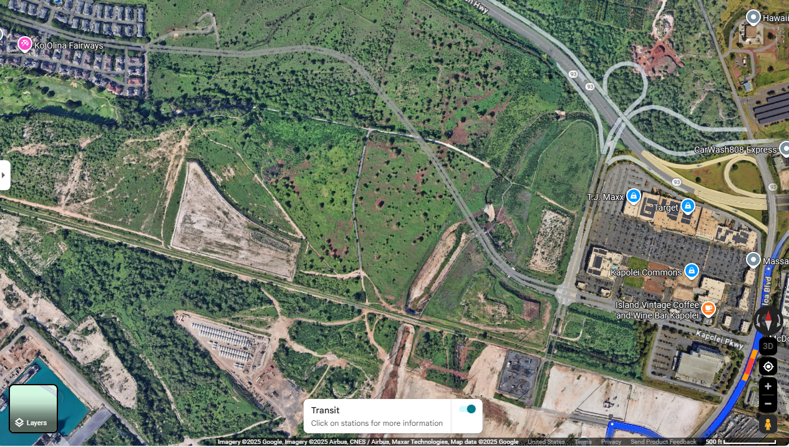
- Road connection, such as the Kapolei Parkway that is supposed to connect to Ko Olina. Currently it is fenced. No access. NB members expect it to be more like Waikiki with easy access in and out.

- Development happened fast but with very poor planning – making money in return, but poor planning and ignore a larger scale connectivity.
- Challenge – people don’t get super involved – not a lot of activists, so board members always have to be proactive and make sure issues get heard.
Q3: Development over the past 20 years, what’s good what’s bad?
- Ewa by Gentry: houses are close together, it’s clean, organized, HOA does good job keeping streets looking well. Ewa by Gentry is immaculate, upkeep is fantastic.
- Golf courses – West Loch did a good job, especially when adding 3 lanes on east side is actually more than enough. Need to find other ways in and out, such as Kapolei Pkwy.
- Ka Makana Alii mall
- Kroc center, UH West are great addition to the Ewa communities.
- Privately control green areas and vs maintained by the city. Changing the scenario would be great to see.

Recommendations on specific people by topic area:
- Housing: David Alco (Rep for Ewa Beach), Sen Kurt Fevella, CM Augie Tulba, CM Andria Tupola, Mitchel Tynanes (builder and carpenter), Will Espero (?) was a senator run for Council member – they are all gov’t reps. Republicans reps this political climate hard to get things done.
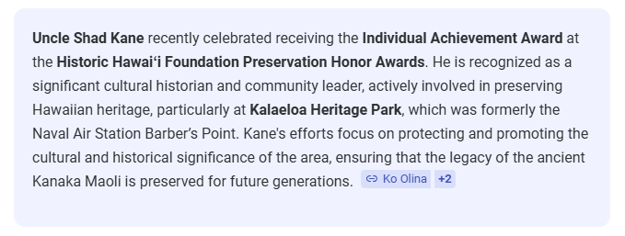
- Community based orgs? Non-profit – Ewa Homestead Project. (Bobby Kent/ Tony/ Chan? We heard very different names here)– HOA 808, Kalaeloa Heritage Park (mentioned uncle who runs the park management?). They might be referring to Shad Kane but need to confirm – Shad Kane: The Cultural Historian – Ko Olina
- Hawaii Bike League Travis ? Uncle David Aki, bus driver, strong feeling about transportation
- Parks: group of pickle ball involved in Ewa Mahiko Park, baseball – biggest sport – season and so packed with people. David Alcos – very involved with Sports and Football leagues.
- Environmental issues: Susan Gorman-Chang for environmental issues (Red Hill, very heavily involved—active and aware of what’s going on), Teri Rojas (outspoken individual).
- Infrastructure: besides roads – infrastructure issues – municipally-owned golf course (West Loch) and Ewa Villages – because they supply irrigation water for a lot of things in Ewa Villages. West Loch – own all infrastructure to get water into the pipes—we have “problem” with that water. Plan to convert? City have a plan and come to HOA to discuss but has never been realized until now.

Additional specific comments by the board:
- Connection with Tripoli with Keoneula Blvd. and Essex road (under federal jurisdiction);
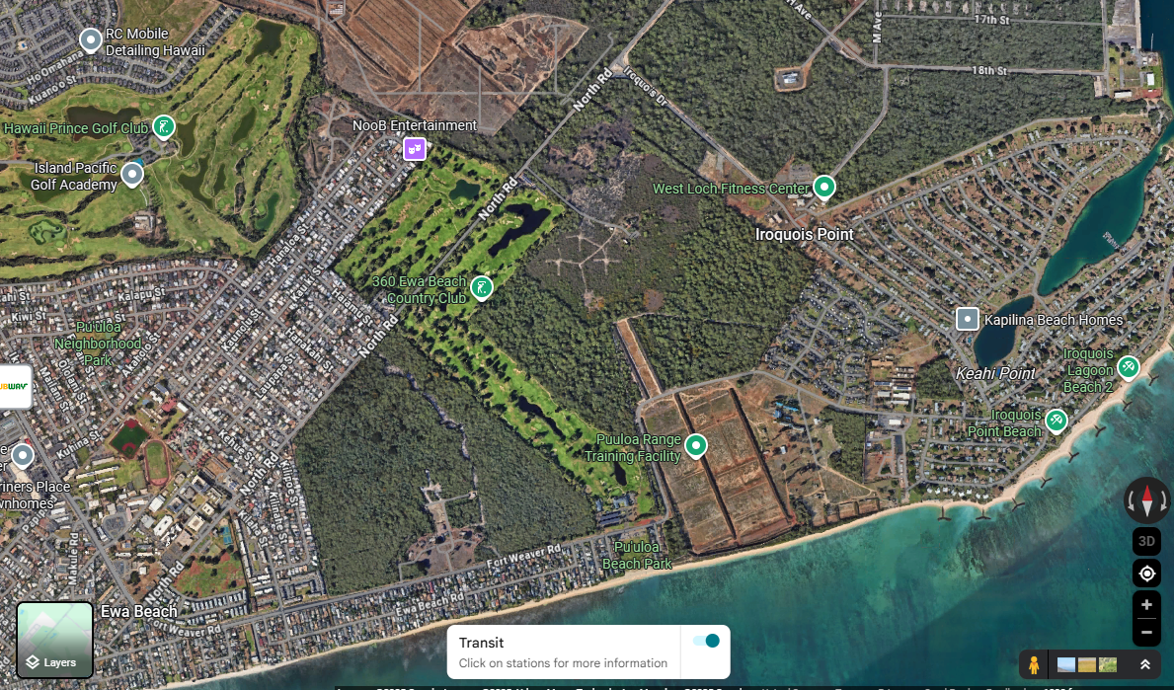
- On the other end, Kapilina Beach Homes is cut off from the Ewa Beach community, used to have and allow bypass, but now access is cut off. North Road is a multi-jurisdictional road – will have to go through roads that don’t have sidewalks – huge problem, connectivity and provide more access between Kapilina and Ewa Beach. Did they mean this Cormorant Ave.?
- Leeward bikeway needs to go all the way up to Nanakuli;
- Keona Road (?) that connects to Asing Community Park, just under Ft Weaver and into Ho’opili could be another way to navigate around (?) Mentioned it being City property, right now used for farmers (?), but also dumping road, gate always open for people to come and dump. If activated it could take us all the way to Ko Olina. Are they talking about a small portion of where Farrington Highway and Old Ft Weaver Road is?;
- Expolsive Safety Arc area – fence off the whole arc? Status? It’s Federal land. It will not be AgLand;
- Backside up to Makakilo that connects to H-1 freeway
- Connection to Ko Olina (from Kapolei Pkwy)
- Bypass “Kulikuli” pass (?) Not sure if I jot it down correctly but I know there is Kolekole Pass up in the mauka, further west of Ewa;
- Bike path related, shared used path in Ft. Weaver Road, also the one by Safeway is a little sketchy—did they mean the shared use east portion of Ft. Weaver Rd.?. Safety-wise improvements.
- ORTP Document – Keoneula Rd coming into Kalaeloa using Essex and Tripoli used to be in the Plan 2030. Leeward bikeway was taken out. NB are trying to get these two back in the plan.
- West Loch Fairways development—NB suggests to speak with HOA—West Loch Fairways Association | West Loch Fairways Association.
- Many communities sees over 30% military (West loch fairway) on 2-4 year assignment then they move away. Many buy local homes as investment then rent it out. While these neighborhoods have a lot of turn over, older neighborhoods are mostly local residents.
- Need new high school, everyone goes to Campbell HS, 3500 enrollment.

